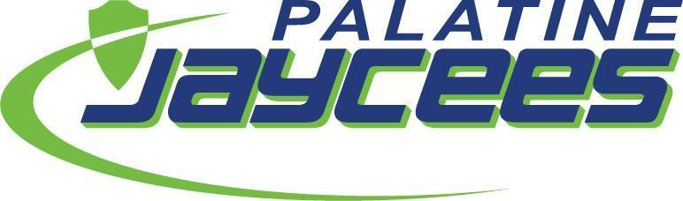

Palatine Jaycees New Member Cheat Sheet 2023

Where do I find information on upcoming projects?
- Palatine Jaycees Facebook Group: We are pretty active and add our projects to the group regularly: https://www.facebook.com/groups/palatinejaycees/
- Events calendar: https://palatinejaycees.org/events/
- GMs (General Meetings): This is where we present new projects, review current projects and recap projects. We meet the 3rd Thursday of the Month at Arlington Lanes (3435 N Kennicott Ave, Arlington Heights, IL 60004) beginning at 7:30 pm. Meetings are also held virtually.
- Insight Newsletter: We send one out every month to the members – look in your Spam/Promotions folder if you do not see it.
- Your Local Director: They will be in contact to help you stay informed

I have a great idea for a project, who do I contact to get it started?
- Social gatherings and fun activities – Courtney Kulig (Chapter Management VP)
- Community projects – Megan O’Brien (Community VP)
- Fundraisers for the chapter – Amanda Carlstrom (Admin VP)
- Learning new skills – Ali Schnackel (Individual Development VP)

What do I need for a General Meeting (GM)?
- Cash! We have a $3 beverage fee, and we have a raffle every month for a good cause.
- PMGs (Project Management Guide) If you are running a project, you will write a PMG to efficiently run an event. Ask any board VP to help you with this process.
- The agenda: Grab one when you come in. It has the schedule for the evening. It also has the Creed on the back.

What projects are the Palatine Jaycees known for?
- Hometown Fest
- Easter Egg Hunt
- Fall Back Brew Fest
- STEAM Fair
- Annual Christmas Tree Sale

Who do the Palatine Jaycees partner with in the community?
- Palatine Park District
- Village of Palatine
- Palatine Township
- Palatine School District #15 and District #211
- Palatine Chamber of Commerce
- Palatine Kiwanis
- Palatine American Legion Post 690

