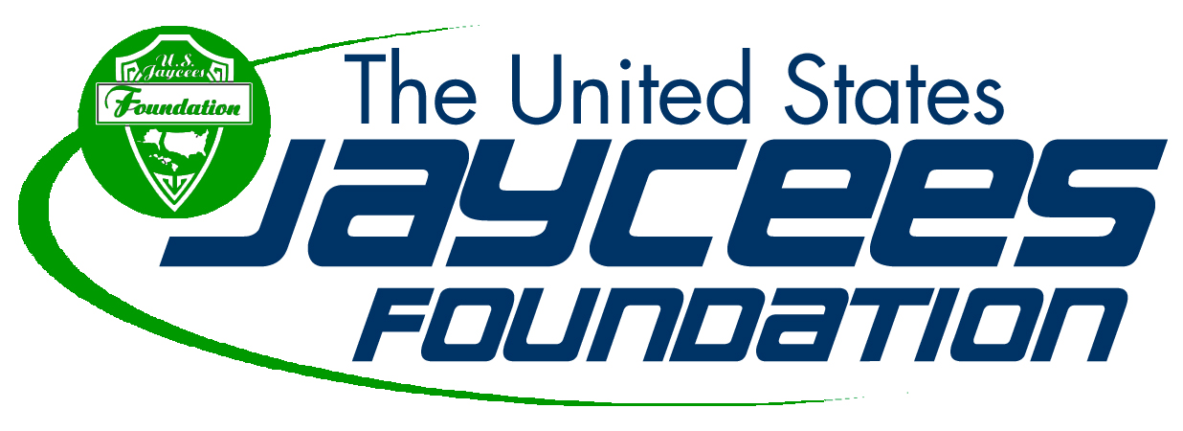
State and Local Chapter Impact Grant Guidelines
US Jaycees Foundation, Inc.
Attn: Grant Request
PO Box 3941
Chesterfield, MO 63006

The application must contain sufficient information for consideration. Items of interest are:

- Has your organization applied for grants from other sources, i.e. chapter, or State Foundations?
- State and Local chapter submissions will be reviewed 90 days prior to the event and/or 30 days prior to a Foundation Meeting.
- Funds will be released up to the funded amount upon receipt of the final report.
- If funds are not used for the intended use, then they must be returned to the Foundation
- Any unused funds must be returned to the Foundation within 30 days of project completion.
- The Foundation will discuss grant applications with the National organization as needed.
- State and Local submissions must be authorized by the President of the entity
- Grants will not be given for funds that are passed through to another 3rd party entity
- Any grant awarded is considered a temporally restricted conditional grant, contingent upon the event occurring.
- The Foundation trustees may suspend any rules due to special circumstances.
- Please send completed form to submit@usjayceesfoundation.com

This request form must be received 30 days prior to the US Jaycees Foundation Meeting at which it will be considered.

Requestor: | Date submitted:
Submitted by: | Title:
Address
City | State | Zip
Phone | Email
Total Amount Requested: | Signature of Requestor:
Signature of State or Local Chapter President:

State and Local Chapter Impact Grant Application Form

Please answer the following questions and include substantiating documentation

What is the main purpose of the project for which you are requesting financial assistance?

What are the specific goals to be achieved with the project?

What is the total cost of the project?

If travel is involved, please indicate the places to be visited:

Please list key individuals involved in this project, and what are their roles?

Indicate the proposed commencement and completion dates of the project?

What is the potential benefit of this project to your National Organization, your Local Organization, your community or persons involved?

Please provide any other comments which you feel may be appropriate in support of this application:

------------------------------------------US Jaycees Foundation Use Only---------------------------------------

Received Date: By:

Grant Reviewer: Approved/ Denied

Recommended Funding Amount: Date:

Foundation Decision Funding Amount: Date:

_______________________________ __________________________
US Jaycees Foundation Chair US Jaycees Foundation Treasurer

Send to: US Jaycees Foundation, Inc. Attn: Grant Request, PO Box 3941, Chesterfield, MO 63006
submit@usjayceesfoundation.com

